

West Wales Regional Athletics Council

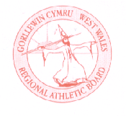
Minutes – West Wales Regional Athletics Council
Friday 11th April 2025
Microsoft Teams Meeting
__________________________________________________________________________________________
Present: Rob Campion Chairman
Nathan Jones Secretary
Andrew Jenkins Afan Nedd Tawe Schools Athletic Association
Lisa Campion Track & Field Committee Representative
Nigel Jones Officials Committee Representative (Endurance)
Owain Schiavone FMR Committee Representative
Jennifer Boyce Pembrokeshire Harriers
Helen Williams Llanelli AAC
Derek Osborne (Junior Open)

_______________________________________________________________________________________

Apologies: Les Cuthbert, Gareth Harries, Aled Jones-Davies
_______________________________________________________________________________________

Actions from Previous Meeting
Starter Kit - currently stored in Neath ready for West Wales outdoor championships.
Gerry Batty Award – check where trophy is to give to Gracie.
Photo finish course – happened in Swansea on 8th March. Need to check with Zoe who attended from West Wales.
_______________________________________________________________________________________

- Discussion

- West Wales indoor and UK inter counties
Day 2 of the West Wales Indoor Championships in mid-February attracted a good turnout for 60m, 60m hurdles and shot. Financially, it was much better in 2025 than in 2024.
Athletes travelled to Nottingham for the UK Inter Counties, good numbers in the juniors and some good teams fielded however it was struggle to find under 20 and seniors willing to attend, due to various reasons.

- West Wales Junior Open - dates
Brecon – May 18; Swansea – June 7; Carmarthen – August 2. Entries will open for the first event next week. License being applied, track booked, chief officials.

- West Wales Outdoor Championships – May 10th
West Wales Outdoor Championships at Swansea on May 10, under 11 events added for 75m and 800m. Event in place, need to ensure there are enough officials and volunteers.

- Inter-Regional events – Caerphilly / Inter Regional Championship July
West Wales to host the 2025 edition of the Inter Regional Championships. 12th July booked Carmarthen, licence has been applied and first aid. Timetable is fixed with the odd year version - half event timetable.
Caerphilly 10K is the Welsh inter-regional 10K championships, 2 women agreed 4 spaces remaining. 5 men agreed 1 space remaining.

__________________________________________________________________________________________
- Information – Reports

- General Council
Nothing to update in the recent meeting.

- Track and Field Committees
Nothing to update, postponed to 23rd April.

- Officials Secretary
Nothing to report.

- Officials Committee
11 attended course for Race Directors in Carmarthen at the end of March. Verifying records – age group and master records discussed.

- Road Running/Cross Country Committee
Welsh Schools and Inter Schools XC
Welsh Schools issued a consultation with various options:
Event to remain combined, Schools and Inter Regional to be held separately, Schools replaced with a relay and Inter Regional to be stand-along (not a relay) Moving towards separating both events, more discussion to be had.

- FMR Committee
Welsh trail half marathon championships won by Josh Griffiths at Nant Yr Arian Silver Trail Half Marathon last month, team selected for the International race. Welsh Junior Mountain Championships at Y Fron near Caernarfon in July.
British & Irish International race on 13th September. Athletes selected for events abroad to contribute £75 towards travel. Anglo-Celtic Plate 100km, few West Wales athletes selected.

- Welfare Officer
Nothing to update.
_______________________________________________________________________________________

- Financial Report

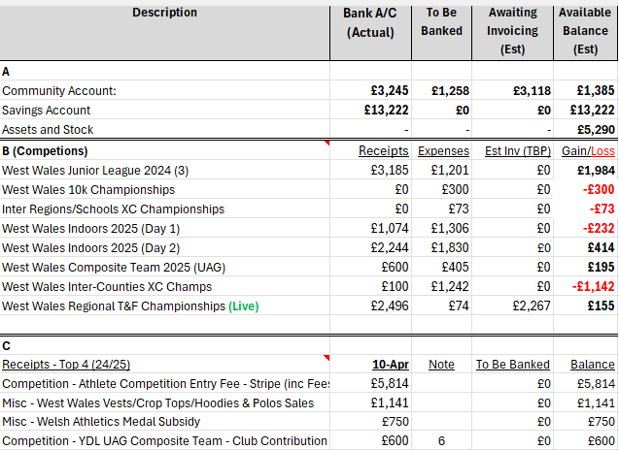
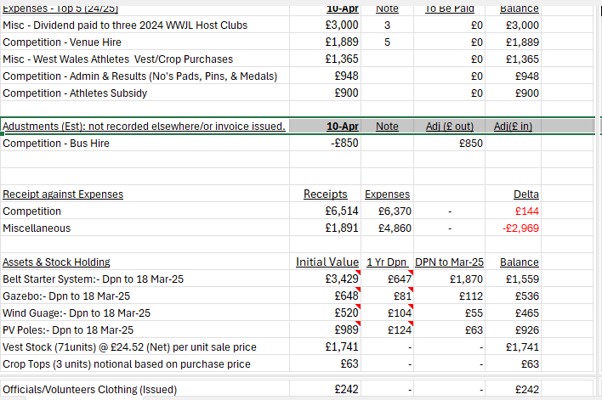
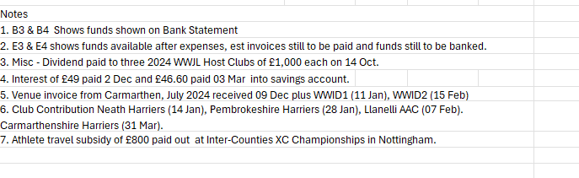

Discussion/agreement
1.£850 bus hire proposed for UK YDL UAG meeting at Yate. Agreed
2. When is Open Track/Stripe likely to be opened for collection of fees from the WWJDL at Brecon (18 May). 18 April
3. Discuss PF + Bounty (£350) use at WWJL meetings. As an offset for lack of timekeepers. Would help, depends on anyone being available
4. Discuss proposed Athletes/Officials/ Coaches/ Team Managers and Supporters bus ticketing charges to Yate. Rob to lead. Proposed bus prices agreed
5. Discus reimbursement of Non participating Club Tech Officials travel costs at WWJL meetings. Officials outside the region
6. Are there likely to be any Grants from Welsh Athletics during the year. Region meeting next week

- AOB

- Age Group proposals distributed; questions raised will be sent to meeting with James Williams.
- Assistant coaches opportunity – local course for Pembrokeshire Harriers. Course in Ammanford soon, however 1 space left. There was one in Aberystwyth recently.

- Date of Next Meeting Friday 13th June at 6:30pm – Canolfan Gwili, Hendy (in person/online)

